1. Water Bottle
2. Design some furniture
3. Try to make a model of something on your desk/near you with accurate dimensions to the real object
4. Fuselage
   1. Tips: you HAVE to layout everything in 2D sketching first. You’ll use the points as references on the 3D sketch.
   2. 2D sketch: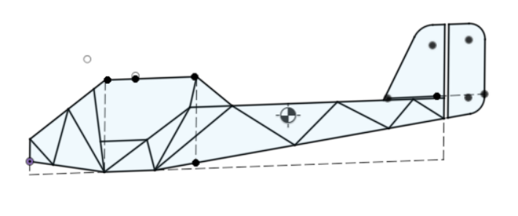
   3. 3D sketch: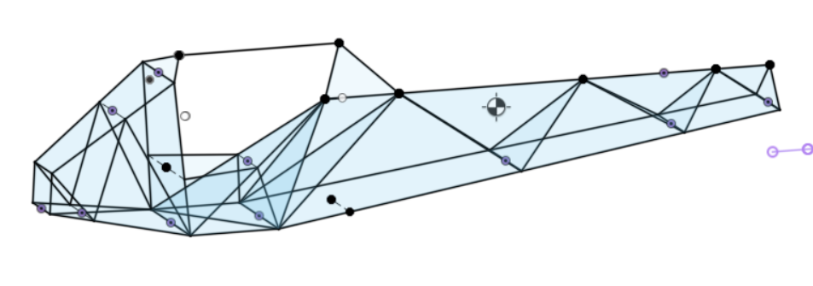
   4. Together: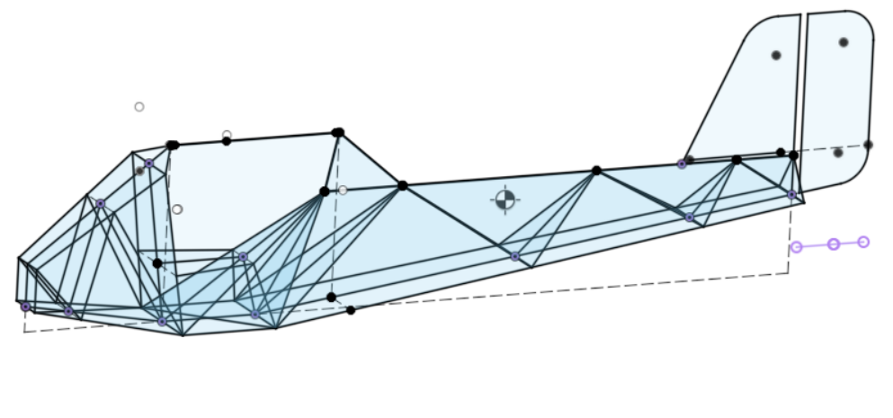
   5. Just try to make any structure of a plane - it doesn’t have to actually be usable. You can find methods/ advice in design>fuselage
   6. 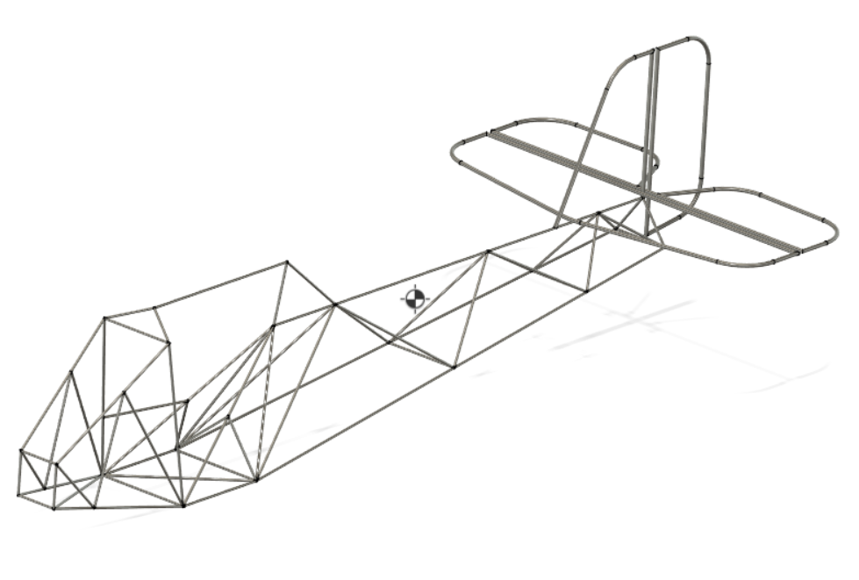
5. Gusseted cube
   1. Gussets: 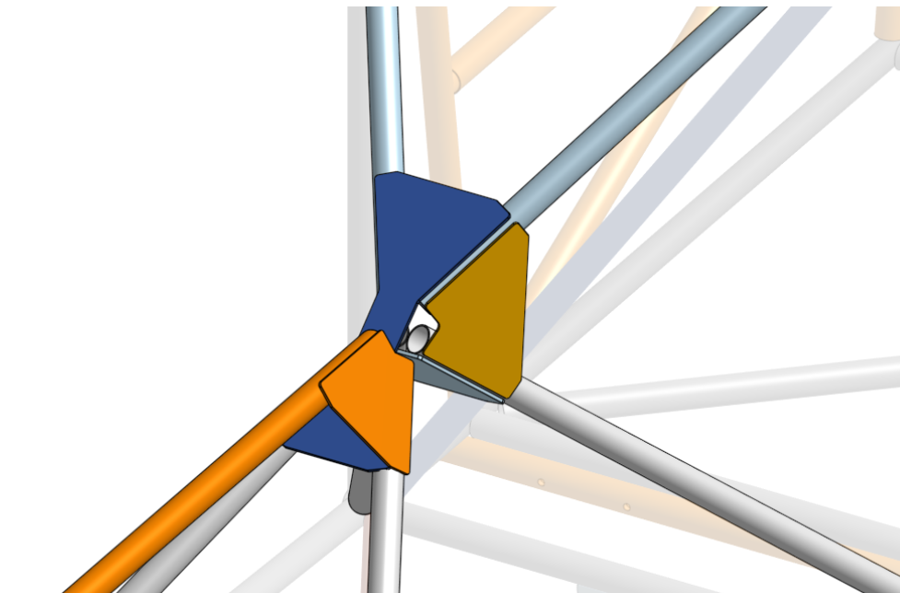
   2. So the tubes would not be welded and instead stuck together with metal plates
   3. You can also add the holes for [rivets / bolts](https://docs.google.com/presentation/d/19gXyAHE4jGXGHkCztBAgxPs54U8kvqfUaQdSxiaMTq0/edit#slide=id.gb9aaddddcc_3_161)
   4. Tips: Use the hole tool. Play around with the construction tools. They’re REALLY helpful for anything beyond basic shapes on a flat sketch. 